Schedule II-H-5.2
Page 36 of 37

PUC DOCKET NO.
ONCOR ELECTRIC DELIVERY COMPANY LLC
ADJUSTED WEATHER STATION DATA
FOR THE TEST YEAR ENDING DECEMBER 31, 2024

SPONSOR: D. E. NELSON

WEATHER SITE LOCATION & RESIDENTIAL CDD WEIGHT PERCENTAGES

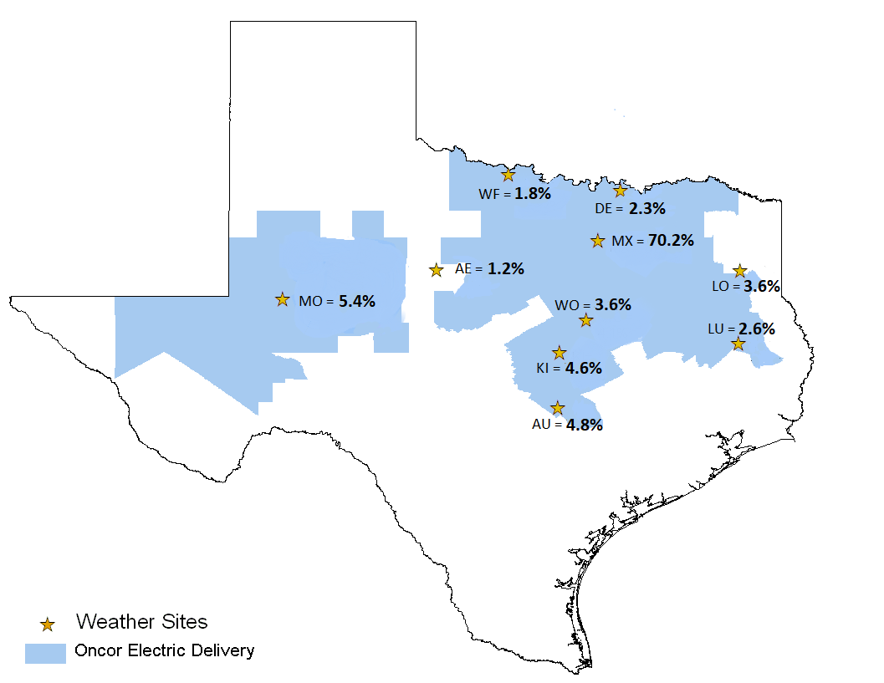

Schedule II-H-5.2
Page 37 of 37

PUC DOCKET NO.
ONCOR ELECTRIC DELIVERY COMPANY LLC
ADJUSTED WEATHER STATION DATA
FOR THE TEST YEAR ENDING DECEMBER 31, 2024

SPONSOR: D. E. NELSON

WEATHER SITE LOCATION & RESIDENTIAL HDD WEIGHT PERCENTAGES

